Evidencing the impact of the Primary Sports Premium

Schools must use the funding to make additional and sustainable improvements to the quality of PE and sport they offer. This means that you should use the Primary PE and Sport Premium to:

- develop or add to the PE and sport activities that your school already offers
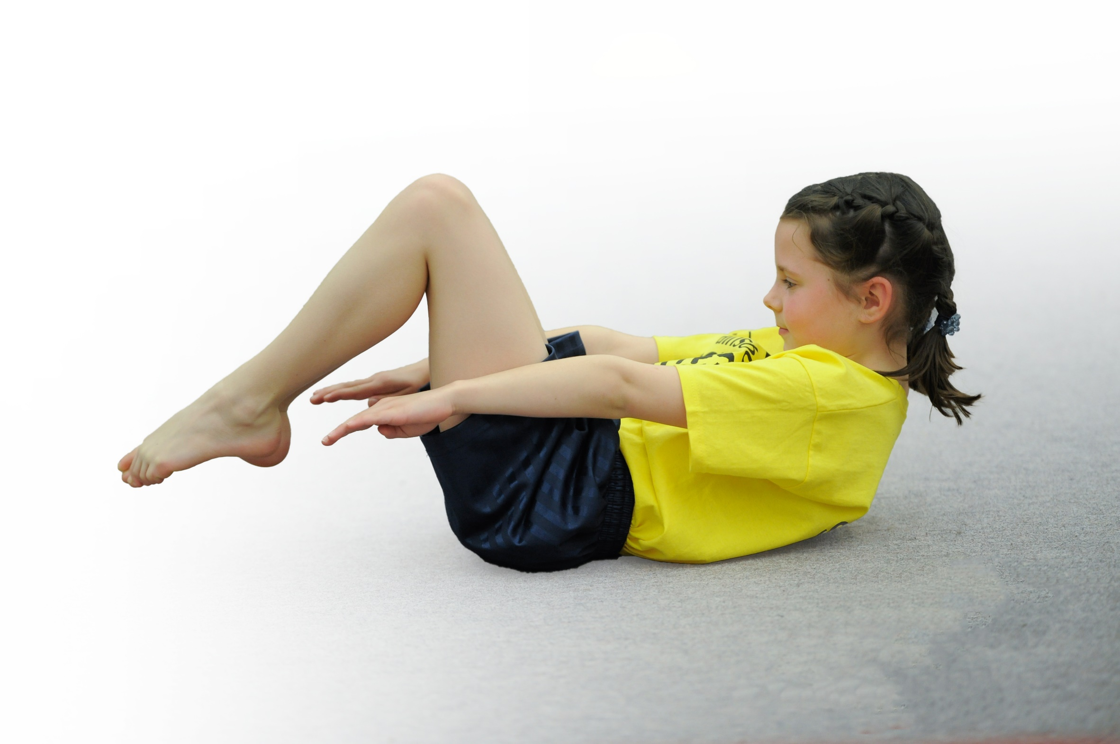
- build capacity and capability within the school to ensure that improvements made now will benefit pupils joining the school in future years

Please visit gov.uk for the revised DfE guidance including the 5 key indicators across which schools should demonstrate an improvement. This document will help you to review your provision and to report your spend. DfE encourages schools to use this template as an effective way of meeting the reporting requirements of the Primary PE and Sport Premium.

We recommend you start by reflecting on the impact of current provision and reviewing the previous spend.
Under the Ofsted Schools Inspection Framework, inspectors will assess how effectively leaders use
the Primary PE and Sport Premium and measure its impact on outcomes for pupils, and how effectively governors hold them to account
for this.

Schools are required to publish details of how they spend this funding as well as on the impact it has on pupils’ PE
and sport participation and attainment.
We recommend regularly updating the table and
publishing it on your website as evidence
of your ongoing review into how you are using the money
to secure maximum, sustainable impact. To see an example of how to complete the table please click HERE.

Support for review and reflection - considering the 5 key indicators from DfE, what development needs are a priority for your setting and your students now and why? Use the space below to reflect on previous spend, identify current need and priorities for the future.

Key achievements to date: up to July 2020 | Areas for further improvement and baseline evidence of need:
1: The engagement of all pupils in regular physical activity – kick-starting healthy active lifestyles:  Mr Ibbett has planned a progressive broad and balance curriculum.  All classes are engaged in regular PE lessons with an outstanding PE specialist.  Teachers are teaching good-outstanding PE lessons after receiving high quality CPD and with the support of the REAL PE resources.  We have a large variety of extra-curricular programs running throughout the year – after school clubs that caters for children from KS1-KS2 ranging from competitive to participation sports.  The Sports Leaders program is growing with UPKS2 children leading session for KS1.  Children are developing skills and attainment is high.  Attitudes towards PE and a healthy lifestyle are continuing to grow with children showing high engaging in all PE lessons.  2: The profile of PE and sport being raised across the school as a tool for whole school improvement:  PE and school Sport has a high profile at St Ann’s Well Academy. Mr Ibbett has coordinated effectively with outside providers and been challenging in his expectations of high quality PE.  PE is a major part of the school curriculum, with PE lessons and clubs running regularly for all year groups.  The children enjoy PE and aspire to be in the school teams, clubs are well attended and over-subscribed.  Growth in extra curriculum provision has enabled significant increase in the number of children taking part in external competitions – our gifted and talented children have opportunities to represent the school.  PE assemblies have celebrated PE achievement inside and outside of school.  The school has launched a Sports Newsletter to engage parents with our school sport.  Class Dojo has been used to share sporting success to our parent community.  Current and ex male and female football players have been invited into the school to hold aspiration assemblies.  The school took part in the Aldi Sports Stickers competition and received two bags of free kit.  The school has achieved the Gold School Games Mark for 2019 and School Games Recognition Award 2020  3: Increased confidence, knowledge and skills of all staff in teaching PE and sport:  Nottingham Forest provides weekly PE CPD (4 sessions per week).  PE leader to attended additional PE leadership training.  Equipment has been bought to resource our new curriculum and ensure that staff have what they need to teach good PE.  Staff from the wider school community have been targeted to develop as sports coaches to lead afterschool clubs.  Additional PE training identified for specific class members  4: Broader experience of a range of sports and activities offered to all pupils  St Ann’s Well Academy aims to give our children a broad and varied PE curriculum, enabling children to learn many different skills and make progress in many different activities.  As stated previously we also have extensive sporting extra-curricular provision on offer which means that the children are able to experience a wide range of activities and sports ranging from competitive to participatory and KS1-KS2.  Access taster sessions offered throughout the year.  KS1 Children and year 4 to attend the L.E.A.D. Bushcraft events in the summer.  Year 5 and 6 pupils to attend L.E.A.D Athletics event.  Children from Years 3, 4, 5 and 6 have taken part in their respective Mega Fest at Harvey Haddon – a sporting participation day.  Nottingham Tennis delivered the Tennis Road Show to all children in KS1.  5: Increased participation in competitive sport:  Competitive sport is part of the school curriculum and extra-curricular program  Pupils across KS1 and 2 have taken part in Multi Sport Mega Fests at Harvey Haddon.  Pupils in year 1 took part in an infant agility festival.  Pupils from years 5 & 6 have signed up for a mini basketball league, enabling them to participate in several basketball fixtures throughout the school year.  The school had its first girls football team from years 4, 5 & 6 take part in a girls football tournament organized by Nottingham Forest.  The school has close links with other L.E.A.D. schools and as a result has been able to use this for competitive sport. The children participated in many fixtures throughout the school year.  Girls from Year 5/6 took part in a Netball Tournament at the Nottingham Girl’s High School and won their group.  Year 4 took part in the indoor athletics competition reaching the semi finals by coming first in their group.  The school competed in L.E.A.D. Athletics event competing against all other L.E.A.D. schools at Harvey Haden Athletics Centre. | 1: The engagement of all pupils in regular physical activity – kick-starting healthy active lifestyles:  Increase attainment of children.  Increase the variety of sports pupils have access to / taster sessions.  Increase links with outside agencies.  Develop the school curriculum further and embed to ensure progression across school.  Improve staff confidence and competence in delivering quality PE sessions.  2: The profile of PE and sport being raised across the school as a tool for whole school improvement:  Hold an annual Sports Achievement assembly to celebrate children who have develop in sport.  Increase number of images of sporting success around school.  Increase communication with parents through tweets and newsletters.  Increase intra-school sports competition.  Continue celebrating and identify all types of sporting and PE achievement across the school.  Work with children to create an aspiration sports brand that can be used for sports kits and other materials.  Continue to explore opportunities for external speakers to hold assemblies.  3: Increased confidence, knowledge and skills of all staff in teaching PE and sport:  Continue to develop staff confidence through observations and team teaching.  Direct external PE specialists to work all teaching staff across the school- focusing on their individual needs.  Hold learning walks to observer and develop staff in the teaching of our curriculum.  Continue to seek CPD opportunities for new and current staff members.  Look for opportunities for PE coordinator to team teach PE with staff members.  Embed the progressive school curriculum to support staff in the teaching of their PE lessons.  4: Broader experience of a range of sports and activities offered to all pupils  To continue to provide / research a range of sporting, dance and outdoor activities to the PE curriculum (taster sessions).  To continue to make links and review current with outside agencies and sports clubs to ensure provision is of high quality.  To ensure that extra-curricula activities build into our whole school PE and Sport program in developing our children’s attitude and develop of PE.  5: Increased participation in competitive sport:  To continue to access / attend a range of competitive sporting events.  To focus on key sports that our children enjoy, build on their skill level and achieve more in external events.  To continue to create a sporting culture across school where children are proud to represent the school at external events.  To target all children across the school to ensure that they are giving opportunities to shine.

Meeting national curriculum requirements for swimming and water safety | Please complete all of the below:
What percentage of your Year 6 pupils could swim competently, confidently and proficiently over a distance of at least 25m when they left your primary school at the end of last academic year? | Year incomplete due to Covid-19 school closures
What percentage of your Year 6 pupils could use a range of strokes effectively [for example, front crawl, backstroke and breaststroke] when they left your primary school at the end of last academic year? | Year incomplete due to Covid-19 school closures
What percentage of your Year 6 pupils could perform safe self-rescue in different water-based situations when they left your primary school at the end of last academic year? | Year incomplete due to Covid-19 school closures
Schools can choose to use the Primary PE and Sport Premium to provide additional provision for swimming but this must be for activity over and above the national curriculum requirements. Have you used it in this way? | Year incomplete due to Covid-19 school closures
Swimming Plan For 2020-21
For the coming year, the school will be changing its swimming provision plan in order to increase the number of children leaving our school able to swim at the expected standard.

All children in Year 4 and 5 will take part in a two-week intensive block (ECAS) where they will swim for one hour each day. Their swimming lessons will also be supported through classroom lessons around water safety and life saving skills.

We aim for more children to reach the expected standard through this program.

Action Plan and Budget Tracking
Capture your intended annual spend against the 5 key indicators. Clarify the success criteria and evidence of impact that you intend to measure to evaluate for students today and for the future.

Academic Year: 2020/2021 | Total fund allocated: £17,800 | Date Updated: 24th July 2020
Key indicator 1: The engagement of all pupils in regular physical activity – Chief Medical Officer guidelines recommend that primary school children undertake at least 30 minutes of physical activity a day in school
School focus with clarity on intended impact on pupils: | Actions to achieve: | Funding allocated: | Evidence and impact: | Sustainability and suggested next steps:
To offer at least two hours a week of high quality Physical Education/School Sport for every child in Key Stage 1 & 2  To ensure PE resources are available, appropriate and fit for purpose  To evidence pupil learning, progress and attainment in PE | Purchase Jasmine online resources for REAL PE Scheme  Develop a broad PE curriculum with many different activities e.g.  - Specialist football coaching through Nottingham Forest - x 4 lessons each week  - Learn by Design dance lessons x 2 lessons  - Taster sessions – i.e – basketball training sessions, rugby and cricket (through Nottingham High School, Nottm City and Outlaws) etc.  Further develop sports leaders.  Young Sports Leaders to attend annual conference.  Children in Year 4 and 5 take part in new swimming program.  Provide a range of PE equipment that is safe and appropriate for all children throughout school (audit of resources needs to be carried out).  PE assessment trackers subscription  Mr Ibbett to track and monitor progress through learning walks and monitoring conversations. | £245  £2,500  £2,275  £3,000  £1,500  £250  £300  £100  Total £10,170 | Impact:  Children have many opportunities to be active  Children increase their physical literacy and life skills  100% of children feel confident to participate in PE and sport  100% of children report that they enjoy sport  Teachers are teaching good PE lessons across with school with improved pedagogy.  Evidence:  PE policy  Extra-curricular timetable  Diary dates  Photographs  Learning Walks  LEAD Quality Assurance Deep Dive  Impact:  Resources are organised and of high quality to meet the needs of the curriculum.  Resources are bought with specific aims to enhance curriculum  Evidence:  Order forms  Equipment  Impact:  100% of children are making good progress in physical Education  Evidence:  DC Pro assessment trackers  Learning walks  Monitoring interviews with external providers and teachers. | REAL PE scheme to ensure long term, sustainable high-quality PE lessons in school  Continue to improve PE curriculum by developing progression expectations across the school  Continue to work with external provides to provide high quality extra curricula- activities.  Continue to target all children across the school so that they take up extra curricula activities to make clubs full.  Review new swimming program and plan for next year’s provision.  Continue to purchase new and appropriate equipment so that children can access a high quality PE and Sport experience.  Continue to improve attainment  Plan in monitoring and learning walk cycle to understand the teaching of PE across the school.
Key indicator 2: The profile of PE and sport being raised across the school as a tool for whole school improvement
School focus with clarity on intended impact on pupils: | Actions to achieve: | Funding allocated: | Evidence and impact: | Sustainability and suggested next steps:
To continue to raise the profile of sport throughout the school and with parents | Make parents and children aware of how sport is encouraged and taught in school through class dojo, twitter and school newsletters.  Results and achievements celebrated in assembly  Update / review St Ann’s Well Academy ‘celebrating sporting success board’.  Post participation and success in sport onto Class Dojo  Competition launched to design school sporting logo leading to materials being professionally produced by a graphic designer.  Purchase new kit for our sports teams.  PE leadership time (1/2 day x 6)  Review our whole school PE policy reflecting current practice and curriculum. | £70  £500  £600  Total: £1,070 | Impact:  Parents and children celebrate school success.  Celebrate sporting achievements outside of school.  Children are motivated to take up extra-curricular clubs and play for the school teams.  Children have sporting role models in school (sports leaders)  Children across the school have aspiration to represent the school in sport.  Through sports leaders, KS1 have calmer and more active playtimes.  Evidence:  Achievements and extra -curricular opportunities celebrated in assembly to children and parents.  Observations at playtimes. | Increase the number of intra-school competition – links to L.E.A.D schools.  Continue with sport profile raising through Class Dojo, Newsletters and display board.  Invite parents to sports event when appropriate.  Hold an ambitious sports day.  Develop long term sports brand for the school.

Key indicator 3: Increased confidence, knowledge and skills of all staff in teaching PE and sport
School focus with clarity on intended  impact on pupils: | Actions to achieve: | Funding  allocated: | Evidence and impact: | Sustainability and suggested  next steps:
To give staff the skills and confidence to deliver Physical Education lessons | Staff targeted to attend specific CPD to boost their skill set in PE.  PE subject leader to attend appropriate PE leadership development courses.  All staff to work along side outside provides for continued professional development. | £300  £400  Total: £700 | Impact:  Teachers feel confident in the teaching of PE and deliver good PE lessons.  Use of external providers is targeted towards a longer- term whole plan of development  Teachers take ownership of the delivery of PE lessons.  Evidence:  Communication with staff  Staff questionnaires  Learning walks to monitor staff confidence in teaching PE  LEAD Quality Assurance Deep Dive | Continue to use REAL PE in-school to support teacher development  New teacher training when needed.  Subject leader to organise coaching observations/learning walks and the use of IRIS to capture quality PE lessons.  Further embedding of curriculum to ensure staff are confident in what children need to be taught in PE.
Key indicator 4: Broader experience of a range of sports and activities offered to all pupils
School focus with clarity on intended  impact on pupils: | Actions to achieve: | Funding  allocated: | Evidence and impact: | Sustainability and suggested  next steps:
To provide a range of sporting, dance and outdoor activities to the PE curriculum  To provide a range extra curriculum sports clubs | Take part in taster sessions offered by external providers such as:  - High School – i.e. netball, football  - Nottingham Outlaws Rugby Team – rugby coaching.  - Tennis Roadshow  To continue partnership work with EPIC and Forest to take part in external opportunities  To encourage children to take part in the EPIC community games and SAS FC training  Pupils in yrs 5 and 6 to participate in sports training in football, basketball and athletics weekly linked to competitive leagues.  Members of staff deliver extra curricula clubs including netball and multi-sports  Member of staff to coach a basketball / football team/athletics (sport subject to change) and enter appropriate competitions (yrs 5 & 6).  External coaches to coach e.g. basketball / football/athletics team (sport subject to change) and enter appropriate competitions (KS2).  Learn by Design coach to deliver a high quality dance club – in a view to entering dance competitions and school performances.  EPIC to deliver 2 after school clubs sports clubs per week | £1,500  £500  (£1,575)  (£1,575)  (£875)  £2,000  Total £4,000 | Impact:  Children have many opportunities to be active in a variety of ways, in PE lessons, extra-curricular clubs, playtimes, visits and through sporting events  Children increase their physical literacy  Children feel confident to participate in PE and sport.  Children enjoy sport and want to take part in external opportunities.  Evidence:  PE Long term Plan 2019-2020  Timetable of additional activities  Record of participation  Extra-curricular timetable | Ensure that sport, dance and outdoor activities-feed into a wider school sport plan  To review extracurricular opportunities  Continue to take part in taster sessions  Continue to access alternative provision – external partners / providers.  Continue to develop staff who deliver extra curricula clubs  To continue to source new opportunities with current and new partners.
Key indicator 5: Increased participation in competitive sport
School focus with clarity on intended  impact on pupils: | Actions to achieve: | Funding  allocated: | Evidence and impact: | Sustainability and suggested  next steps:
To continue increase our participation in competitive sports | School to increase available space for afterschool sports provision by hiring Brendon Lawrence Sports Hall one night a week.  Staff member to set up and coach a football/ basketball/ basketball team (upper KS2). Entering competitions as and when. Sport focus is subject to change.  External coaches to coach e.g. basketball / football team/athletics (sport subject to change) and enter appropriate competitions (KS2).  Learn by Design coach to deliver a high quality dance club – in a view to entering dance competitions.  Transport costs to participate in other externally provided competitions (sports calendar not available yet) | £750  £1,575  £1,575  See above  £2,500  Total £6,400 | Impact:  Children across the school have many opportunities for competition.  Children are succeeding in sport including athletics, mixed football, girls football, basketball as well as various other sports.  Children improve their skills and confidence.  Raising profile of sport throughout the school, giving the children among the lower years strong aspirational ambitions.  Evidence:  Fixture lists  School Sport Newsletters  Competition results  Photographs  PE display  Assemblies to highlight pupils who take part in external events. | Continue to participate in Nottingham City sporting competitions (chosen by PE Leader).  Continue to participate in L.E.A.D events (chosen by PE Leader).  Continue to develop school focus sports -basketball, football, netball and athletics  Increase links with outside agencies and increase number of children participating in competition outside of school.  Target children to give them a chance to shine  To increase participation in competitive sports  - GT after school club at Brendon Laurence Sports Centre (yrs 5 / 6) (football / basketball focus) – all year round  - Mixed ability and gender football after school club (yrs 3 / 4) – all year round  - Develop clubs to target girls including girls football and netball  - Design and purchase a PE competition.

